**Jan 16 2025**

🥁🥁Jonathan “the indie game industry is awful” Blow:

🥁🥁

<https://youtu.be/XhfZ1QEl-2s?si=LumAYLykFQVB2MLm>

🥁🥁

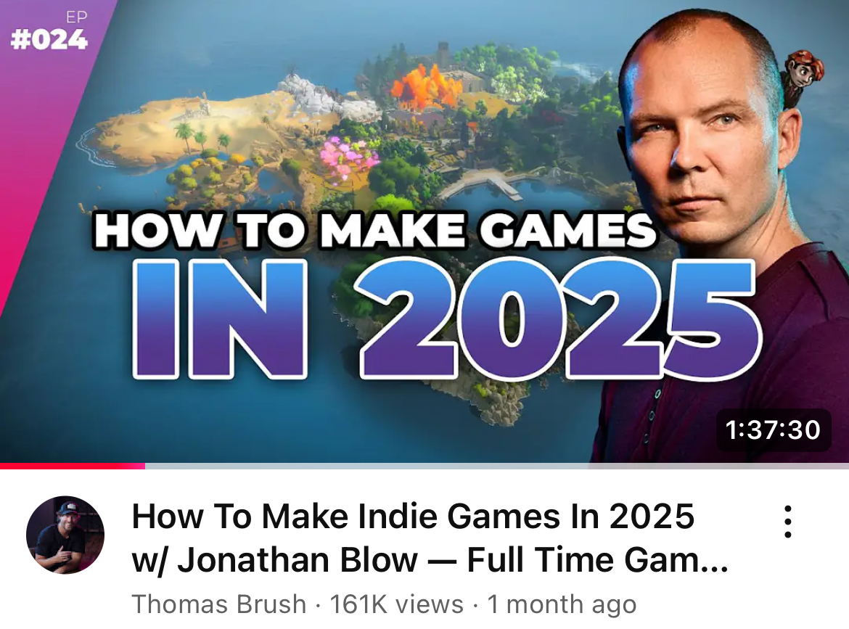

0. **Big list of games**

1. The game (game #1, game #2)
2. The game type
   1. Strategy/simulation
      1. “RTS”
      2. “Colony” / “Colony Sim”
      3. “City Building”
3. Why
   1. Social commentary
   2. Simulation
   3. Simulation > social commentary
      1. *These games do well on Twitch!
4. Market
   1. Yuuuuuuge
      1. {Video games}
      2. {PC/Mac/Linux videogames}
         1. - PC
         2. - Mac
         3. - Linux
5. 4.1 Major studios
   1. Paradox Interactive
   2. [Studio that makes] Animal Crossing, @ Nintendo
   3. Wube Software
   4. Jonathan Braid, the studio-onto-himself
   5. Matthias Linda, the Chained Echoes guy
6. Games we’re not like
   1. Disco Elysium
   2. “Gacha” games (WuWa, Genshin, etc.)
   3. AAA-games (any, but – e.g., Breath of the Wild; compare)
      1. We’re a Single-A studio
      2. $100 million dollars is too much

**Big list of games:**

*~~ Games that teach you something about the world ~~*

Historical simulator games (sometimes called “4X”):

* The *Civilization* series (IV, V, and VI)
* **Any** Paradox Studio game
  + Crusader Kings 3
  + Europa Universalis IV
  + Hearts of Iron IV
* The *Total War* franchise
* Anno 1800

Futuristic simulator games:

* (Paradox) Stellaris
* Offworld Trading Company

City/Colony-builder games:

* Rimworld
* Against the Storm
* Timberborn
* Cities:Skylines
* Dwarf Fortress, *is the classic*

Builder-style games:

* Factorio
* Satisfactory
* Dyson Sphere Program

Outdoor-style games:

* Rust
* Outworld
* Arc
* Kenshi
* No Man’s Sky

1. **The game**

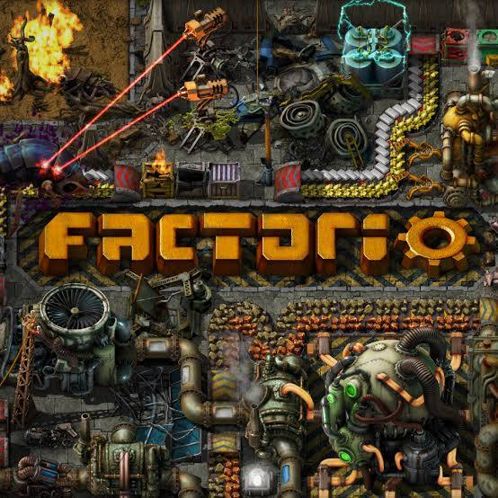 **plus** 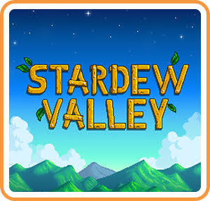

That’s it..

(game 2: <https://bsky.app/profile/personofpersonhood.bsky.social/post/3lfsi5iaqu227> )

1. **The game type**

The central thing we care about with videogames is that they are a *way to see*.

Video Games can teach you something about the world.

When I was in middle school, in the year **1999**, I played a game called **Age of Empires 2.**

**It let me reenact famous scenes** across human history, controlling an army, a town center, a number of defenseless villagers, and progressing throughout stages in technology the way prehistoric man did.

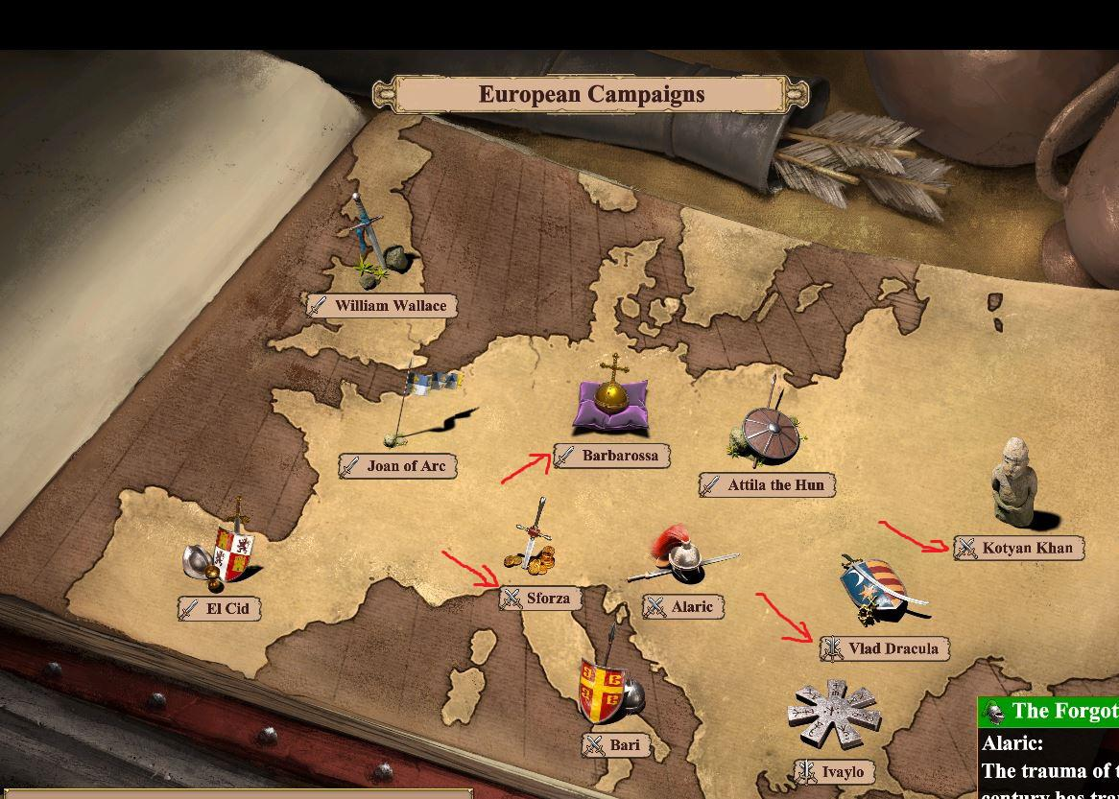

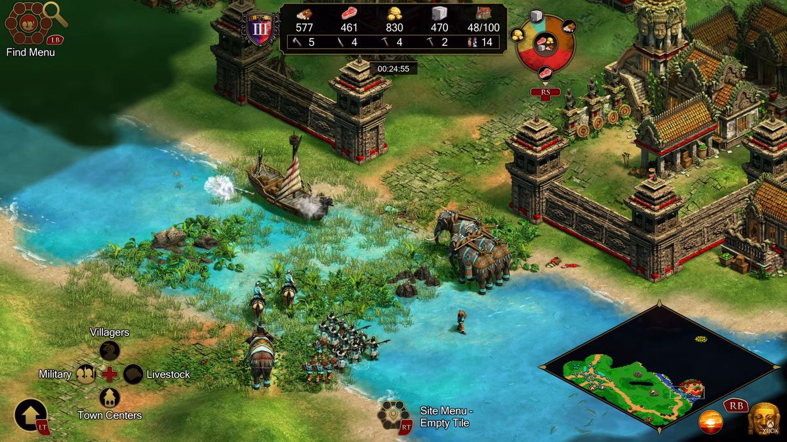 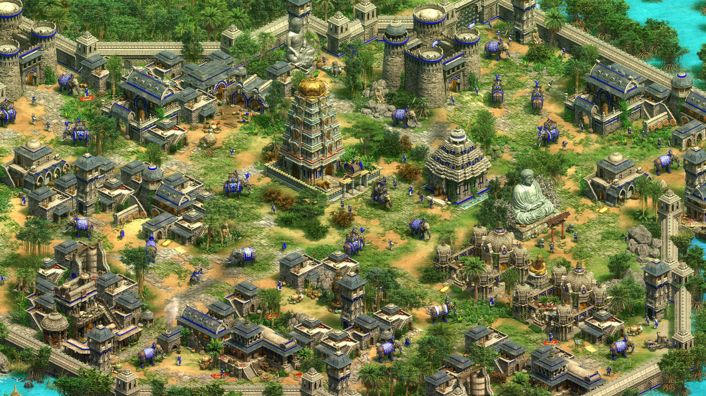

**2. The game type (con’t)**

I like games that teach you something about the world.

*Simulation games*

* **Factorio**, by the Czech studio **Wube Software**, is the #1 game studio in the world.
  + 
  + Actually, read the whole thread.
  + <https://x.com/search?q=from%3Apatio11%20factorio&src=typed_query&f=top>
* 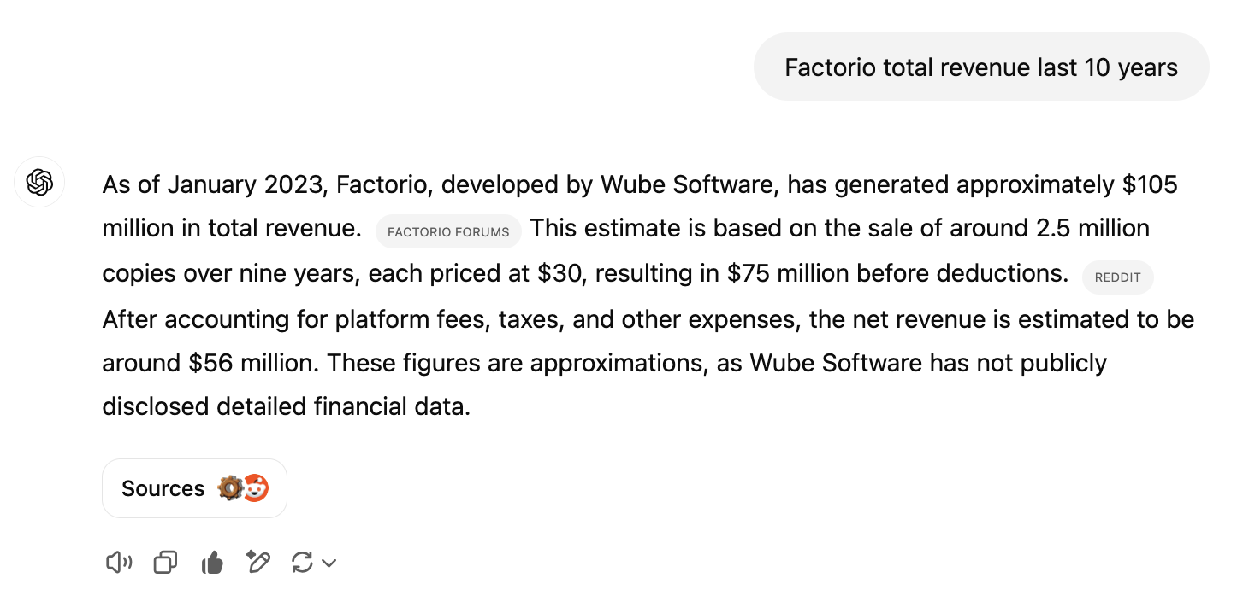
* Minecraft/**notch** is probably a close second. We’re jealous of him.

*Social simulation games*

* **Animal Crossing** total revenue: $3.6 billion
* **Stardew Valley** total revenue: $615 million
* **Minecraft** total revenue: $220 million last year
  + ($3 billion total - yuck)

**2. The game type (con’t)**

*Social simulation is superior to social commentary in every measure.*

People play games that they watch on Twitch.

Streamers play games that get a lot of viewers

(Streamers stream games that are fun to stream}

Social commentary games are fun to stream

(Social commentary games are, usually, not that fun)

Strategy games are fun to play

(People like playing strategy games)

Simulation is the cousin of strategy

*A game that teaches you something about the world*

History is fun,

but the present is more fun

(and the future — very fun)

Fantasy is also fun.

**Example prima:**

* **Roblox**
* **Runescape**
* **Minecraft**
* **Fortnite**
* **CS/1.6/Source/Go**

All of these games:

* Are about the real world
* Huge, massively online “marketplace” experiences

We want smaller games than that.

* **Single player** -> **broadcast audience** (Twitch, Kick, YTG) -> a market.

**Attractive women are engaging**

* Avoid it

—-

What we’re shooting for here is an **indie game development shop**,

that **makes single-player** games, broadcasting to their **livestreaming** audience,

that **teach** viewers and players *something real about the world*,

from the comfort of a hikkikomori shell basement in a decaying and de-industrialized world.

—-

**2. Game type (cont’d)**

Prime inspiration: **Wube Software.**

* *Founded* in 2013
* *Released* Factorio (flagship title) in 2015
* *Took off* in 2015, upon release

Small, 10-12 people, development-led team.

Secondary inspiration**: Lo-Fi games**

* Started in **2006 (!!!)**, alpha in 2011, released in **2018**
* They make a game called *Kenshi*

Tertriary inspiration: **Jon Blow**

4th: Stardew Valley

* Single developer: “ConcernedApe” (name: )
* Started in 2012, released in 2016

5th: Chained Echoes (JRPG - *Best JRPG of all time*)

* Solo developer: Mattias Linda
* Started in 2016, kickstarter in 2019, released in 2022

6th: Notch?

* I don’t really like Notch. For personal reasons. But he did the thing.
  + “Minecraft” or whatever

—

{ *A game that teaches you something about the world* }

* Mission statement

There’s tons of examples of this, spanning genres:

* **Shooter/FPS** type games teach you about guns, vantage points, tactics, team coordination, and often (cf., Modern Warfare 2) about contemporary, or more typically historical (older CoD franchises, Wolfenstein) historical experiences.
* **Historical RTS/Strategy** games obviously teach you about their historical context.
* **Action/Racing** games teach you about cars, and racing.
* **Action/Sports** games teach you about sports, players, teams, and design.

The list goes on.

* **Engineering/automation** games are where our sweet spot is, though.
* Which is Factorio, Satisfactory, Rust, and so on
  + {list like 30 games here}
* **Social/simulation** games are of particular interest to us, as well.
  + Animal Crossing, Stardew Valley, Pikmin, etc.
  + **Dwarf Fortress** is a really key example.

**4. Actual** research / industry analysis:

The robot literally does it all: <https://chatgpt.com/share/679a5829-b344-800e-88fc-44d90fcfe19b>

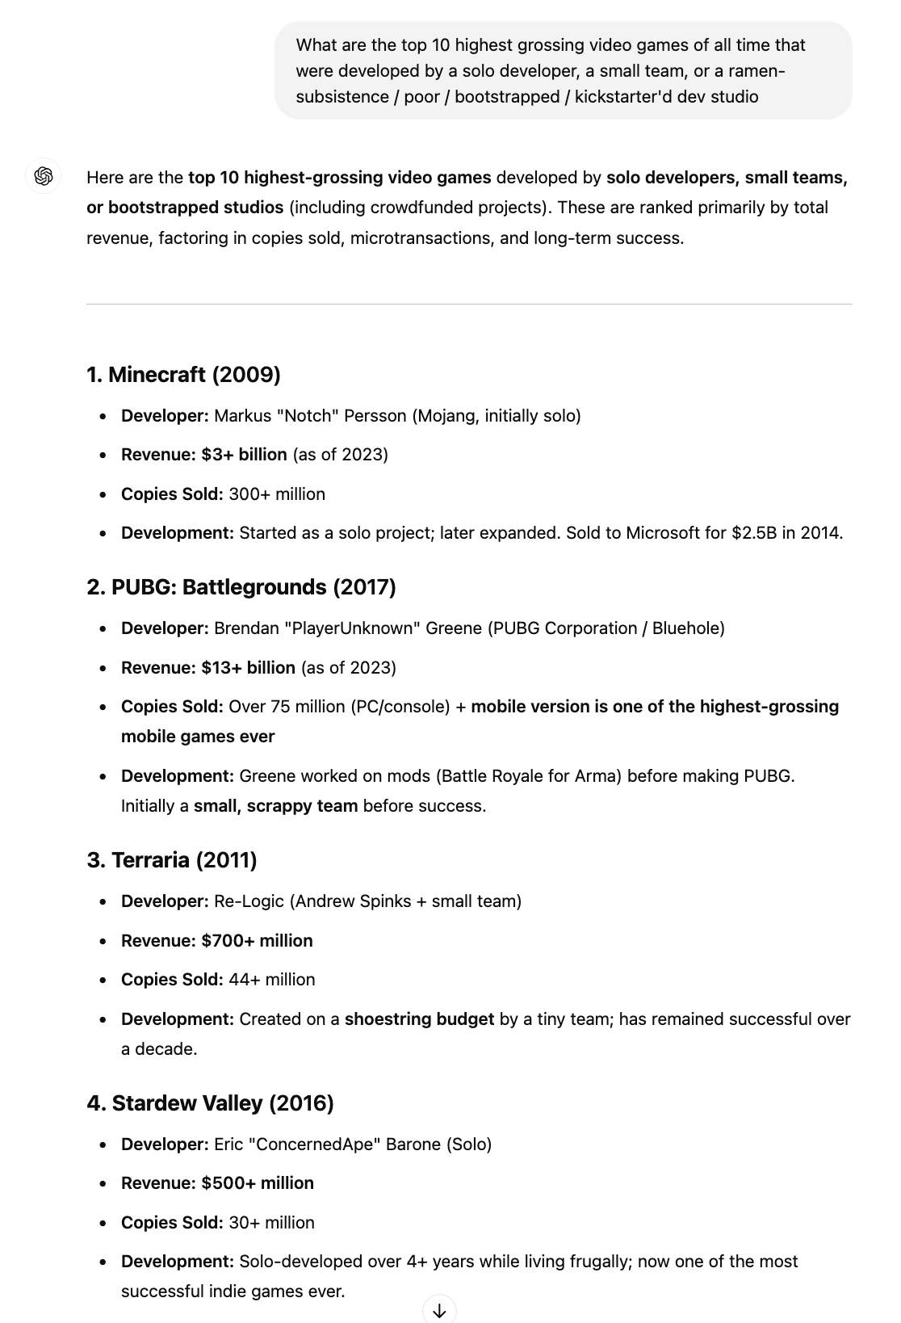

**4. Actual** research / industry analysis:

The robot literally does it all: <https://chatgpt.com/share/679a5829-b344-800e-88fc-44d90fcfe19b>

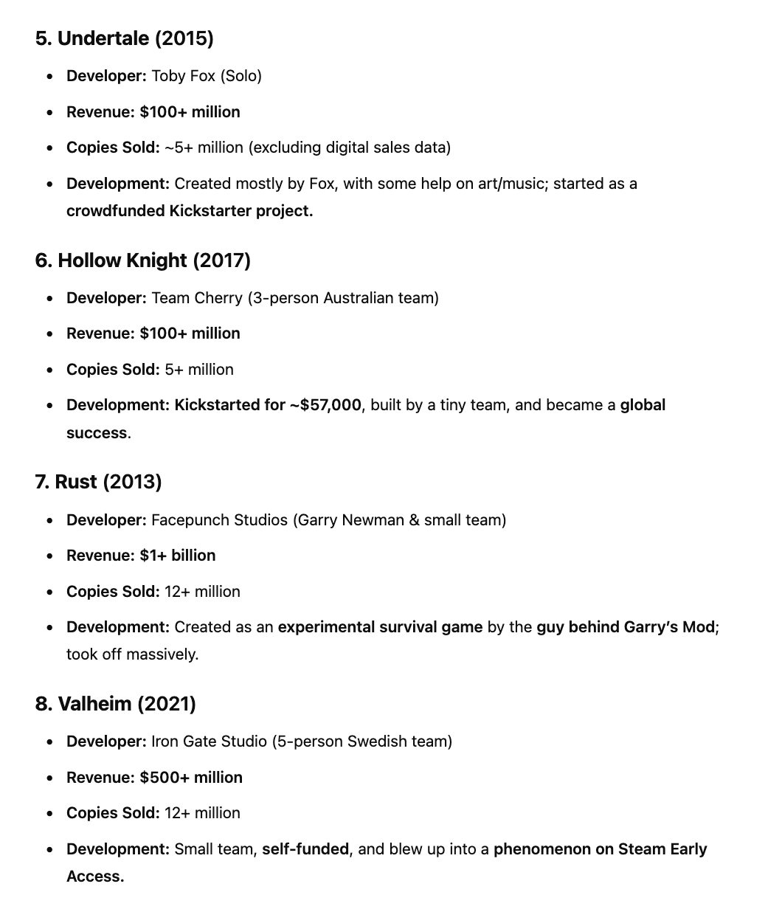

**4. Actual** research / industry analysis:

The robot literally does it all: <https://chatgpt.com/share/679a5829-b344-800e-88fc-44d90fcfe19b>

